Lab Sheet 1

Name : Lokesh Chandra Basu
E.No. : 10114026
Course : Operating Systems Lab

Question 3

Implement Queue Data Structure. Try to implement various queues like Job Queue, Ready Queue, and Waiting Queue using the data structure developed. Initially, we will use PID(Process ID) (an integer) as the data to be stored in these Queues. You should keep in mind that, in future, they can be modified to store Process Control Block(PCB).

Algorithm

Algorithm used :

//to create the Ready Queue
take input from the user for the number of queues in each of the Ready Queue
Initialize count to 0
While count is less then input number
generate a random number to be stored in queue as pID
count = count +1

//to create the Job Queue
take input from the user for the number of queues in each of the Job Queue
Initialize count to 0
While count is less then input number
generate a random number to be stored in queue as pID
count = count +1

//to create the Waiting Queue
take input from the user for the number of queues in each of the Waiting
Queue
Initialize count to 0
While count is less then input number
generate a random number to be stored in queue as pID
count = count +1

//to display the Ready Queue
initialize count to zero again
while count is less then length.readyQueue
display info.readyQueue

//to display the Job Queue
initialize count to zero again
while count is less then length.jobQueue
display info.jobQueue

//to display the Waiting Queue
initialize count to zero again
while count is less then length.waitQueue
display info.waitQueue

Gantt Chart
Procees Execution Tiem(in ms)
P1 5
P2 15
P3 10
P4 7
P5 3

Job Queue with processes and execution time (assuming all arrives at same time) :

P1 | P2 | P3 | P4 | P5
0 5 20 30 37 40

After Long Term Scheduler or Job Scheduler :

Ready Queue :
P1 | P2 | P3 | P4 | P5
0 5 20 30 37 40

time elapsed = 0ms

After Short Term Scheduler or Scheduler Dispatch :

Ready Queue :
P2 | P3 | P4 | P5
5 20 30 37 40

Running Queue :

P1(Running)
0 5

time elapsed = 5ms

Ready Queue :
P3 | P4 | P5
20 30 37 40

Running Queue :

P1(Terminated) | P2(Running)
0 5 20

time elapsed = 20ms (just after P2 terminates) And So on...
Output
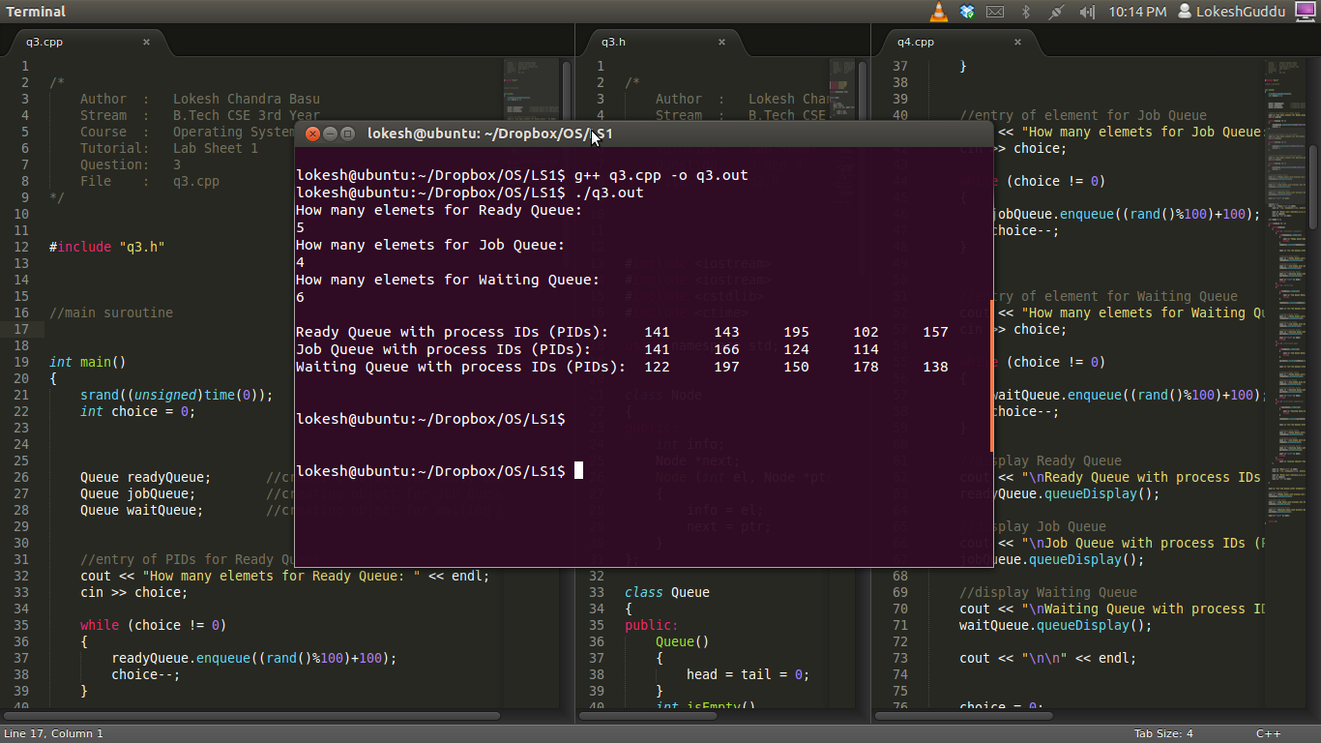
gcc version 4.6.3 (Ubuntu/Linaro 4.6.3-1 ubuntu5)

Question 4

Simulate (Diagrammatically, if Possible) various Process States. Three key strokes (or buttons) can be used as input to represent a scheduler, an interrupt, and the I/O event. The program should be able use the queues designed in question 3.

Solution to question 4

Terminated Processes
Job Queue

Job Scheduler Exit

Interrupt
Running Queue
Ready Queue

Scheduler Dispatch

I/O Event Completion I/O Event Wait

Waiting Queue

Algorithm

Algorithm used :

//to create the Ready Queue
take input from the user for the number of queues in each of the Ready Queue
Initialize count to 0
While count is less then input number
generate a random number to be stored in queue as pID
count = count +1

//to create the Job Queue
take input from the user for the number of queues in each of the Job Queue
Initialize count to 0
While count is less then input number
generate a random number to be stored in queue as pID
count = count +1

//to create the Waiting Queue
take input from the user for the number of queues in each of the Waiting
Queue
Initialize count to 0
While count is less then input number
generate a random number to be stored in queue as pID
count = count +1

to display the Menu with all the options:
    - Scheduler
    - Interrupt
    - I/O Event Wait
    - I/O Event Completion
take input from the user for the operation to perform

switch choice (1 to 4)
perform the operation according to choice

1. scheduler will dequeue Ready Queue and enqueue Running Queue
2. interrupt will dequeue Running Queue and enqueue Ready Queue
3. I/O Event wait will dequeue Running Queue and enqueue Waiting
Queue
4. I/O Event wait will dequeue Waiting Queue and enqueue Ready
Queue

if the choice is other then 1 to 4 then the process ends and displays the
contents of the queues

//to display the Ready Queue
initialize count to zero again
while count is less then length.readyQueue
display info.readyQueue

//to display the Job Queue
initialize count to zero again
while count is less then length.jobQueue
display info.jobQueue

//to display the Waiting Queue
initialize count to zero again
while count is less then length.waitQueue
display info.waitQueue

Output
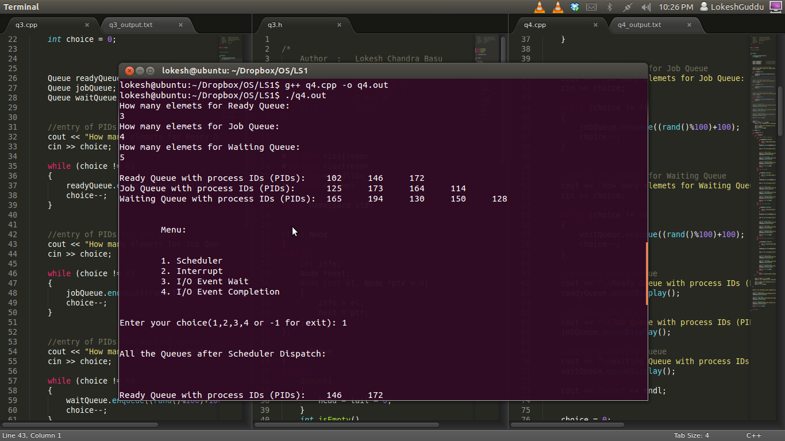
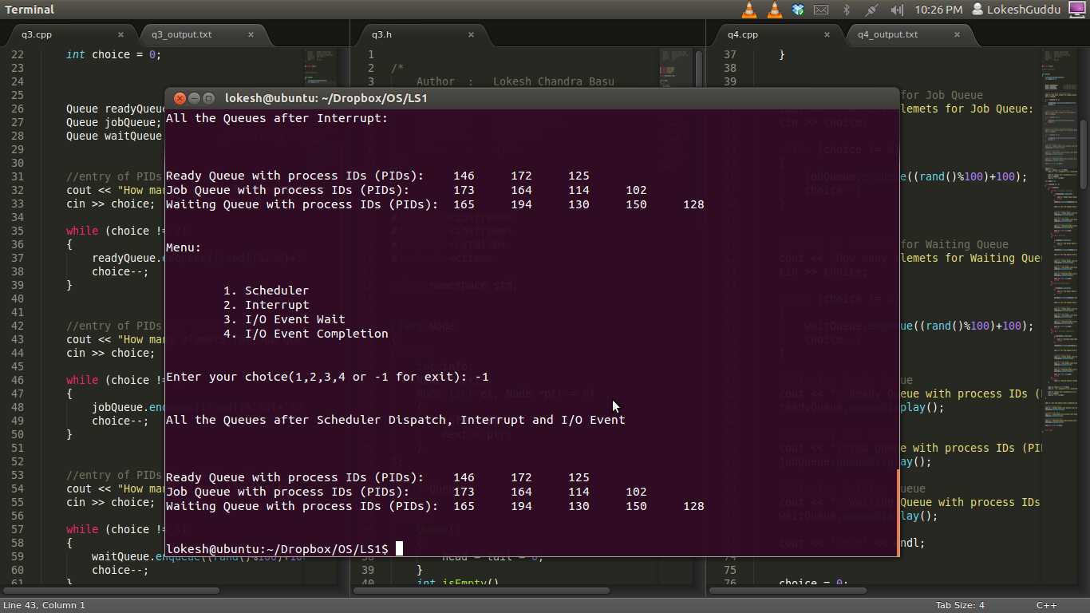
gcc version 4.6.3 (Ubuntu/Linaro 4.6.3-1 ubuntu5)

